RISK ASSESSMENT No: B
HAZARD: MANUAL HANDLING

NATURE OF WORK:
- Any transporting or supporting of a load (including lifting, putting down, pushing, pulling, carrying and moving thereof) by hand or bodily force.

HAZARDS:
- Personal injury

THOSE AT RISK:
- Anyone involved in the moving and handling of objects could be at risk.

POSSIBLE RESULTS:
- Strains and sprains
- Cuts and abrasions
- Crush and trap injuries
- Slipped disc or other back problems
- Hernias

PPE TO BE WORN:
- No specific PPE

CONTROL MEASURES:
- If possible, use mechanical lifting devices or aids (e.g. wheelbarrow).  - Never exceed your personal capabilities, do not be afraid to ask for assistance.  - Free on-line training is available from the County Council.  - The chart on the right gives guideline weights for lifting and lowering, which assumes that the handling is taking place in reasonable working conditions with a load that is easily grasped with both hands by a reasonably fit, well-trained individual.  - Remember - No manual handling activity is completely safe. | 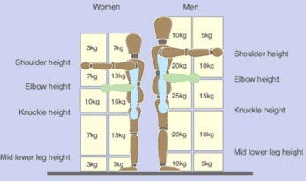

Basic principles of manual handling
- Ensure that the object is light enough to lift, is stable and unlikely to shift or move.
- Heavy or awkward loads should be moved using a handling aid.
- Make sure the route is clear of obstructions.
- Make sure there is somewhere to put the load down wherever it is to be moved to.
- Stand as close to the load as possible, spreading your feet to shoulder width.
- Bend your knees and try and keep the back's natural, upright posture.
- Grasp the load firmly as close to the body as you can.
- Use the legs to lift the load in a smooth motion as this offers more leverage reducing the strain on your back.
- Carry the load close to the body with the elbows tucked into the body.
- Avoid twisting the body as much as possible by turning your feet to position yourself with the load.

